1. 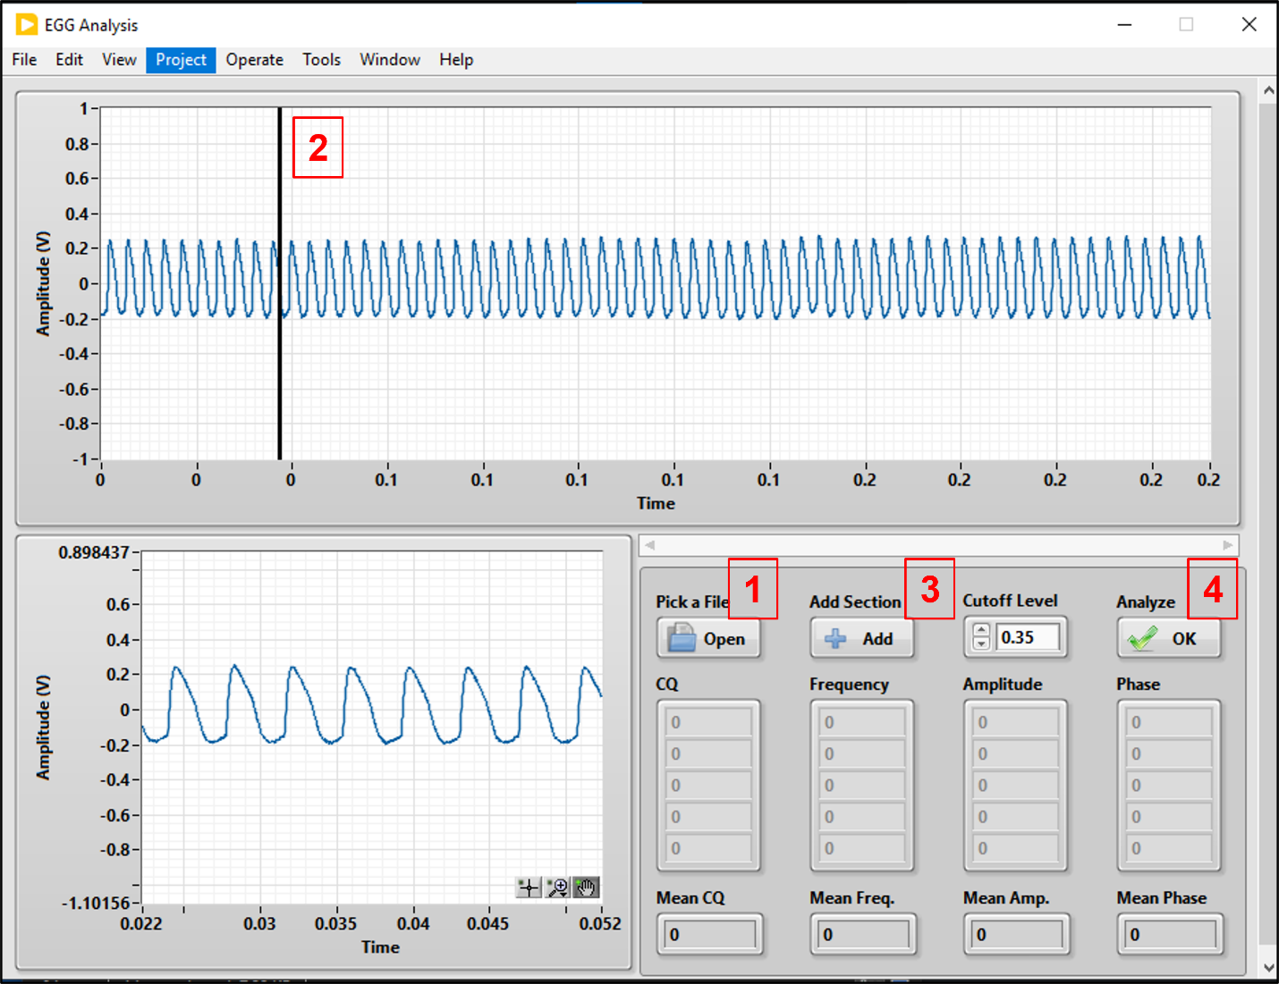Click ‘Open’ and select a wave file of recorded EGG data.
2. Move the cursor (vertical line) left or right to select a segment of data. This segment will appear in the botom left.
3. Whenever you find a segment, click ‘Add Section’.
4. Click ‘Analyze’ to calculate the fundamental frequency, closed quotient, amplitude, and phase of the segment of EGG signal you just added.

Other notes:

* Right now, this program does not save any data.
* You can add and analyze multiple segments.
* Average values from all the segments are shown at the bottom.